Full paper

Author Guidelines for the Online Journal ce/papers
[Title: two lines, 180 characters maximum]
Max Mustermann1 [main author’s first name + surname] | John Doe [1st co-author’s first name + surname] | Jane Roe2 [2st co-author’s first name + surname]
Correspondence
Dr. Joe Doe
Bloggs Technical University
Institute for Bloggs Studies
Any Street 1
12345 Anytown
Email: doe@uxy.edu

1 Affiliation, Town, Country
2 Affiliation, Town, Country
Abstract
[Abstract: 1000 characters maximum] This is a dummy text for detecting typographical errors. You can tell from this text what the letters look like and if any are missing. Sometimes words like Hamburgefonts, Rafgenduks or Handgloves are used to test typefaces. Sometimes sentences containing all the letters of the alphabet. These are called “pangrams”. Here is a very well known one: The quick brown fox jumps over the lazy old dog. Dummy texts often contain sentences written partly in a foreign language (AVAIL and Wefox are testing aussi la Kerning) to test the effect in other languages. Almost all typefaces look good in Latin, for example. Quod erat demonstrandum. Since 1975 most test texts have not included numbers. Consequently, under TypoGb. 204 §, from the year 2034 it will be compulsory to include numbers in 86 % of texts. Failure to observe this requirement will incur a penalty of up to €245 or $368.
Keywords
Article, Science, Know-How, e-olny, PDF [up to 10 keywords, separated by commas]

Introduction
The editorial office decides whether to accept or reject articles submitted according to technical and scientific criteria. By submitting a paper, the author agrees to adhere to the following conditions:
- Articles and essays have to be written by the author himself/herself. He or she must also be the copyright holder of all illustrative material submitted (photographs, drawings). Fees requested subsequently by third parties must be paid by the author.
- The editorial office has the right to change, to supplement or to shorten the text according to language style, structure or content, or to ask the author to do so. Changes may also become necessary due to the particular scientific position of the journal. If the author does not agree to such alterations, he/she may withdraw the article.
The publishers Ernst & Sohn provide a style sheet for creating copy for use with the Microsoft Office word processing system. This document was created with this style sheet as an example, so you can delete the content and work with it directly. Please note that the journal ce/papers is always published in the language of the conference.

Structuring and design of manuscripts

Outline and formal structure
The text length of an article/essay should not exceed 11.000 characters (including spaces) and respectively six printed pages of A4 format including figures, tables and references, and it should be written using a word-processing system, preferably MS Word, in 8,5 point font size and 1,1 line spacing in Verdana font. Please do not make any changes to the paragraph format settings. Longer contributions should be discussed with the editorial office.
The title of a contribution should be short and to the point. The first and family names of all the authors should be listed without any academic degrees on the top of the first page.
Every contribution should begin with an abstract (1000 characters maximum) of its contents.
In addition, a list of up to 5 keywords is required. When writing the text, authors should make every effort to use clear, straightforward language. They should avoid complicated, involved sentences, repetitions and writing in the first person. The manuscript must be ready for printing. The text is to be clearly structured by subheadings and numbered following the decimal system with normally not more than three decimal points. Every article starts with ‘1’ and ends with ‘References’.
We ask the authors to provide a corresponding author with the complete name, including academic title, postal address (preferably the company or institution) as well as e-mail address (no phone or fax).
Authors are requested not to use footnotes, except for author affiliations in the first column. If unavoidable, they should contain only factual information and no references. Footnotes should be numbered consecutively.

Figures and tables
Images and tables are labelled and numbered consecutively with Arabic numerals. Each image and table must be mentioned at least once in the body of the text. Where possible, images and tables should be placed in the body of the text at the end of the section where they are first mentioned. Necessary information regarding the source of the image should be inserted at the end of the caption.
If images consist of individual subfigures, where possible these should be recorded as single images and the figure numbers allocated lower case Arabic letters (e.g. a–f). Where possible as regards length, captions for subfigures should be summarised in one caption.
Table 1 Description of the different types of furnishing
variant | furnishing | baffle board
0 | without | without
1 | 8 office desks | without
2 | 8 office desks | with reflective surface
3 | 8 office desks | with reflective surface

The size of the illustrations is based on the print space:
- minimal width = 88 mm (single-column)
- maximal width = 181 mm (two columns)
- maximal height = 260 mm (full page, portrait format)
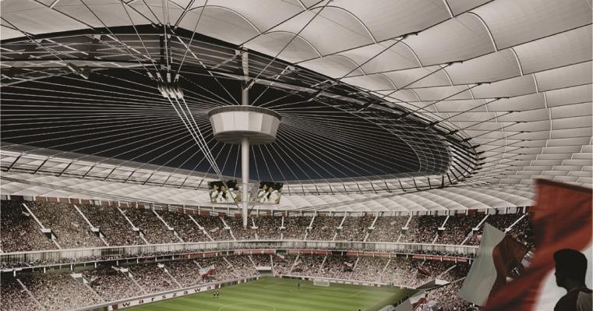
Figure 1 Photos should generally be provided in JPG, PNG, BMP format. A minimum resolution of 150dpi is required. Source: Photographer/Institution

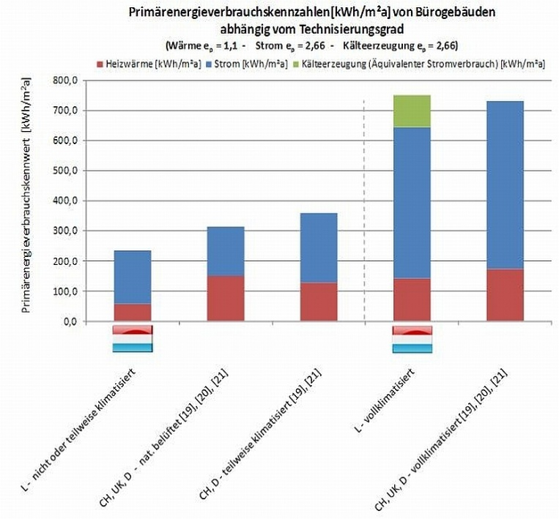
Figure 2 Subfigures should be numbered a), b), c) ... etc. Source: Photographer/Institution
Table 2 Preferred image formats and resolutions
Type of image | Graphics format | Resolution | Width for single-column setting
Technical drawings | PNG (24 bit), TIFF | 300 dpi | 1024 px  (min. 720 px)
Line drawings | Colour: PNG (24 bit), TIFF  B/W: TIFF | 300 dpi  800 dpi | 1024 px (min. 720 px)  2770 px (min. 1600 px)
Photos | JPG, (TIFF) | 300 dpi | 1024 px (min. 720 px)

Symbols
Formulas and other symbols must be the same in texts, illustrations and tables. They should be clearly typed, preferably using a word-processing system (e.g. with a formula editing program) such that they cannot be misread.
Indices and exponents should be clearly subscripted or superscripted. Special formula symbols should be used in compliance with the prevailing norms. In particular, authors should take care not to mix Greek, Roman, Latin and Arabic symbols when typing in upper- or lower-case letters – e.g. γ (gamma), y and Y, o, O and 0 (zero), ω (omega), w und W, Arabic ‘1’ and the lower-case ‘l’ as in ‘letter’. Gothic letters should be replaced by semi-bold characters. Three-part terms are to be avoided wherever possible.

Equations
In order to incorporate equations, please use the MS Word Equations Editor or MathType. Equations (1) should be numbered consecutively:
$e=m∙c^{2}$ (1)

Sending your manuscript
For submission of manuscripts, please use our online portal “Scholar-One Manuscripts” at the following URL: https://mc.manuscriptcentral.com/cepa
If you are submitting a paper for the first time, you have to register and setup a user account first, using your name and a valid e-mail address. Upon successful login, you can submit new manuscripts in the authors section. The main document should be submitted as a Word document. Corrections and changes that result due to the review
Please make sure that in addition to the submission of your main document you should create a ZIP file containing all your images/figures from the main document and upload this file separately. When encountering any issues during the process please turn to Esther Schleidweiler (eschleidwe@wiley.com) for assistance.
References
References and quotations should be listed at the end of the paper. References should be numbered using Arabic numerals, the number of the reference appearing in the text in square brackets, in the order in which they appear within the text (not sorted alphabetically). The references should be quoted using abbreviated versions according to ISO 690. Within this document the format template List: Literature is available to format references. In the following, some citation examples of monographs and journal articles.
- Hass, R.; Meyer-Ottens, C.; Richter, E. (1993) Stahlbau-Brandschutz-Handbuch. Berlin: Ernst & Sohn.
- Haenel, J.; Kina, J.; Schaumann, P. (1994) Zur Erweiterung des Anwendungsbereiches von Stahlträgerverbundkonstruktionen. Stahlbau 63, H. 4, pp. 279–283.
For further examples, see: Examples style references

